Agriculture and GMOs Name: _________________________ Per: ____
Chapter 10 Date: April 1, 2019
#1 Outline Notes
Directions: Use the power point notes to answer the following questions. This is due at the END of class. Please turn your paper and the class set of notes into Mrs. Gordon.
Produce food through technology (4)
1. 3.
2. 4.
Difference between:
Undernourishment | Overnutrition | Malnutrition

Green Revolution
Depends on what (4 things)? ________________________________________________________________________________________
Positive Effects on NATURAL resources (2)

Negative Effects on NATURAL resources (4)

Monoculture: Def: ______________________________________________________________

Good (1) _________________________________________________________________________

Bad (2) _________________________________________________________________________

Difference between pests and weeds.
______________________________________________________________________________________

How do pests become resistant to pesticides?
_____________________________________________________________________________________
_____________________________________________________________________________________

Biological Control:
What is it? _______________________________________________________________________

How can it go wrong? ______________________________________________________________

IPM: What’s it stand for? ________________________________________________________
List 7 techniques
__________________ ________________________________________ ____________________

____________________ ___________________________________ _______________________

____________________
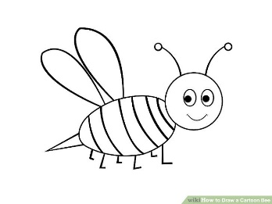
Save the bees! But how (2)?
1.

2.

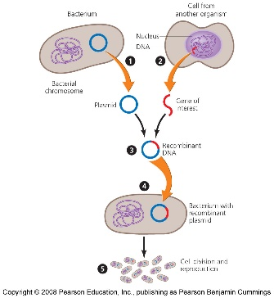
GMOs
Benefits (4) | Risks (2)

Things Biotechnology has done(3):

What are the arguments for Agricultural breeding? __________________________________

______________________________________________________________________________________

Impacts of GM crops
1.
2.
3.
4.
5.

What do the nations say:
US?

Brazil, India, & China?

Zambia?

Why preserve crop diversity (3)?

Ways to preserve crop diversity: Seed Banks
Describe it?

Issues with it?

Feedlots, Aquaculture, Organic Farming
Chapter 10
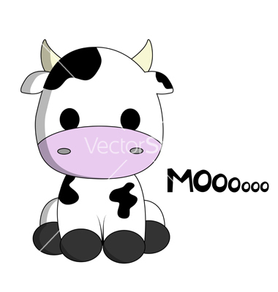
#2 Outline Notes
Feedlots
What is the relationship between commerce and consumption of meat?

CAFO is an acronym for:

Benefits (3) | Drawbacks (3)

Based on energy, why should we all eat as low on the food chain as we possibly can?

Which animal converts grain into meat most efficiently?

Why does producing beef require the MOST space and water instead of chicken?

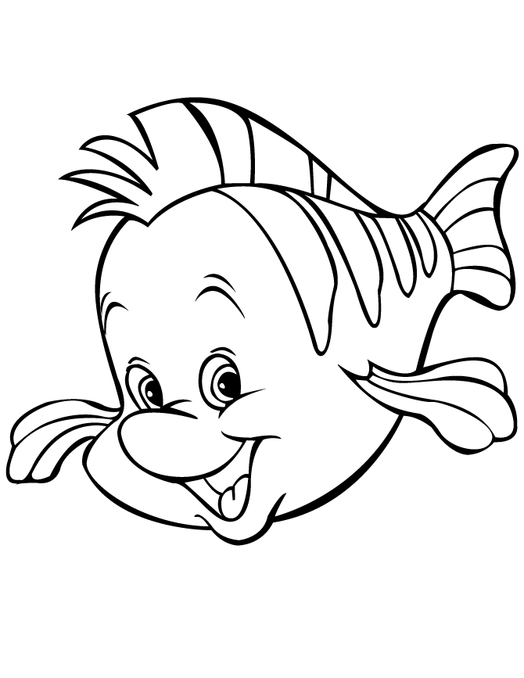
Reflection: What choices can you make per day or week to decrease your consumption of food?

Aquaculture

Why were “fish farms” created and why are they growing rapidly? (2)

Benefits | Drawbacks

Organic Farming for Sustainability
Differences between less-intensive agricultural methods
Sustainable | Low-input | Organic

Market for organic food is increasing stats:
1.

2.

3.

Benefits for FARMERS | Benefits for CONSUMERS

How did the European Union help farmers to convert to organic farming?
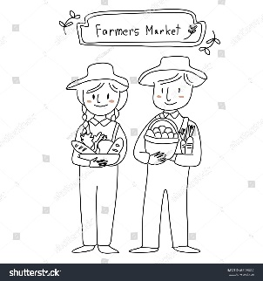

Why haven’t US farmers converted?

Why has organic agriculture succeeded in cities?

What is community-supported agriculture and why would people actually do this?

What is the name of such places in Warner Robins?

