Unit 2: Biodiversity: Environmental Case Study

Reintroducing Wolves to Yellowstone
Directions: Annotate (write a summary statement of the paragraph) EACH paragraph and then answer the questions at the end.
A little more than a century ago, an estimated 100,000 gray, or timber, wolves (Canis Lupis) roamed the western United States. As farmers and ranchers moved west, however, wolves were poisoned, shot, and trapped wherever they could be found. The last wolves were eliminated from the northern Rocky Mountains in the early 1900s. Without a predator to restrain their numbers, elk and deer populations expanded rapidly. In Yellowstone National Park, for instance, the elk herd grew to some 25,000 animals, probably four or five times the vegetation’s carrying capacity. Vegetation was overgrazed, and populations of smaller animals, such as ground squirrels, declined. For several decades, ecologists urged that wolves be reintroduced to control prey populations. These proposals brought howls of angry protest from local ranchers, who see wolves as sinister killers that threaten children, pets, livestock, and the ranching way of life. It took more than 20 years to get approval for wolf reintroduction.
Annotation
In 1995, 31 wolves were trapped in western Canada and relocated to Yellowstone. Once in the park, wolves became established surprisingly quickly. By 2005, there were
165 wolves in 15 packs in Yellowstone and another 850 wolves in Montana, Idaho, and Wyoming. The effects on the ecosystem were immediate and striking. Biodiversity increased noticeably. Fewer elk, deer, and moose meant more food for squirrels, gophers, voles, and mice. Abundant small prey, in turn, led to increased numbers of eagles, hawks, fox, pine martens, and weasels. Large animal carcasses left by the wolves provided a feast for scavengers, such as bears, ravens, and magpies. Nearly half the coyotes, which had become common in the wolf’s absence, were killed by their larger cousins. This helped small mammals that once were coyote prey. Plants such as grasses, forbs, willows, and aspen flourished in the absence of grazing and browsing pressure. Rangers and naturalists were delighted that the ecosystem was back in balance again, while tourists were thrilled to catch a glimpse of a wolf or to hear them howl.
Annotation
Tourists are delighted to see wolves. Surprisingly, these notoriously shy animals have quickly learned they are safe in the park and now hunt in the open valleys during daylight hours. The result is a bonanza for wildlife biologists, who now have thousands of hours of behavioral observations, something that was previously impossible.
Annotation
Not everyone was happy, however, with the reintroduction program. Ranchers continue to regard wolves as a threat to their way of life. In 2005, the government announced new rules that allow ranchers near Yellowstone to shoot wolves they believe are threatening livestock. Previously, you could only shoot a wolf if it had its teeth in the livestock. Animal rights groups denounce this rule, but wildlife managers believe that it won’t imperil the population. Only about 6 percent of wolves cause problems, such as livestock depredations.
Annotation

1

Questions

Directions: Please answer each question in a COMPLETE sentence
- Wolf reintroduction raises some important questions about the purposes of parks. Are they recreational areas or refuges for nature?

- What responsibilities do parks have to their neighbors (and vice versa)? What role do you think science should play in this dispute?

- Suppose you were a wildlife biologist charged with designing an acceptable wolf management program in Yellowstone. What strategies would you use, and where would you start?

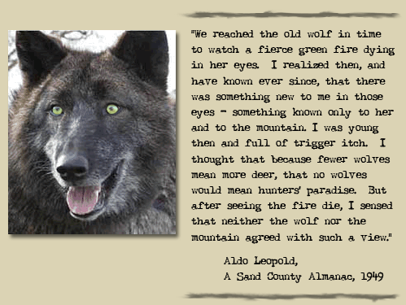

2

