Covalent: Empirical & Molecular Formulas Cornell Notes
Cues |  | Notes (write notes from powerpoint here)
Summary (discuss main ideas and major points…this is homework too!)

Cues) | Notes (write notes from powerpoint here)  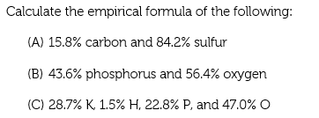
Summary (discuss main ideas and major points…this is homework too!)

Cues |  | Notes (write notes from powerpoint here)  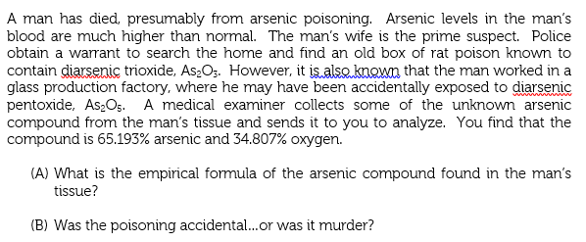
Summary (discuss main ideas and major points…this is homework too!)

Cues) | Notes (write notes from powerpoint here)
Summary (discuss main ideas and major points…this is homework too!)

