Eutrophication Video Name: ____________________________________
https://www.youtube.com/watch?v=wMZ8xfHPNu8
Define these words before the video starts!
- Phytoplankton
- Algae
- Cyanobacteria
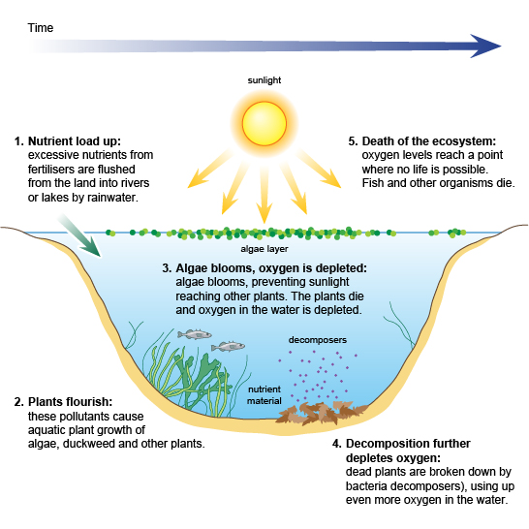
2. Based on the video, what is the difference between hypoxia and anoxia?

3. What are the 4 effects of eutrophication?
1.
2.
3.
4.

4. How can eutrophication lead to biomaginification?

5. Explain the different ways nutrients can come from nonpoint sources.

6. Which is worse: Point sources or Nonpoint sources and why?

