APES Name_______________________________ Date______________

THE SOIL TEXTURAL TRIANGLE PRACTICE NOTES
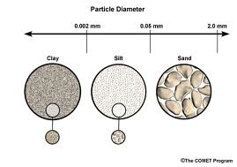
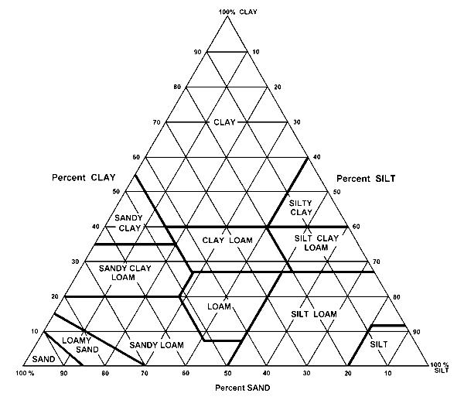

1. Soil Profiles – go to this site APES in A Box: Soil Profiles and take notes on the soil horizons: http://www.youtube.com/watch?v=6Kr3Wj7SeSc

2. Soil Triangle and Characteristics—go to this site APES in a Box: Soil Triangle and take notes: http://www.youtube.com/watch?v=VEgHmgnrWzk

3. How to read a Soil Triangle: http://www.youtube.com/watch?v=bAYzoVliNFQ

4. Now it is your turn to use the Soil Texture Triangle.

Soil Textural Triangle Practice Exercises

% Sand % Silt % Clay Texture Name

- 75 10 15 sandy loam
- 10 83 7 _______________________
c) 20 20 70 _______________________
Soil Texture Worksheet

Directions: Using your soil texture chart and example, determine the following soil textures using the percentages given.

% sand % silt % clay Soil Texture

example 75 10 15 sandy loam

- 42 _____ 37 __________________

- ______ 52 21 __________________

- ______ 35 50 __________________

- 64 30 ______ __________________

- 50 _____ 40 __________________

Now for a challenge!:

- 36 ______ ______ Clay Loam

- _____ ______ 42 Silty Clay

- _____ ______ ______ Loamy sand

- _____ ______ ______ silt loam

Make your own!!

______ ______ ______ __________________

______ ______ ______ __________________

WHAT IS THE DIFFERENCE BETWEEN SAND, SILT AND CLAY
Sand is a naturally occurring granular material composed of finely divided rock and mineral particles. The composition of sand is highly variable, depending on the local rock sources and conditions, but the most common constituent of sand in inland continental settings and non-tropical coastal settings is silica (silicon dioxide, or SiO₂), usually in the form of quartz.
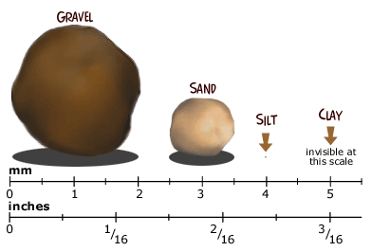
The second most common type of sand is calcium carbonate, for example aragonite, which has mostly been created, over the past half billion years, by various forms of life, like coral and shellfish. It is, for example, the primary form of sand apparent in areas where reefs have dominated the ecosystem for millions of years like the Caribbean.
Silt is granular material of a size somewhere between sand and clay whose mineral origin is quartz and feldspar. Silt may occur as a soil or as suspended sediment (also known as suspended load) in a surface water body. It may also exist as soil deposited at the bottom of a water body. Silt has a moderate specific area with a typically non-sticky, plastic feel. Silt usually has a floury feel when dry, and a slippery feel when wet. Silt can be visually observed with a hand lens.
Clay minerals are typically formed over long periods of time by the gradual chemical weathering of rocks, usually silicate-bearing, by low concentrations of carbonic acid and other diluted solvents. These solvents, usually acidic, migrate through the weathering rock after leaching through upper weathered layers. In addition to the weathering process, some clay minerals are formed by hydrothermal activity. Clay deposits may be formed in place as residual deposits in soil, but thick deposits usually are formed as the result of a secondary sedimentary deposition process after they have been eroded and transported from their original location of formation. Clay deposits are typically associated with very low energy depositional environments such as large lakes and marine basins. The distinction between silt and clay varies by discipline. Geologists and soil scientists usually consider the separation to occur at a particle size of 2 µm (clays being finer than silts), sedimentologists often use 4-5 μm, and colloid chemists use 1 μm.
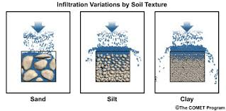
Primary clays, also known as kaolins, are located at the site of formation. Secondary clay deposits have been moved by erosion and water from their primary location

Notes from video!
APES in a Box: Soil Profiles

APES in a Box: Soil Triangle & Characteristics

Sources: Wikipedia

Particle Size: http://www.google.com/imgres?sa=X&biw=1192&bih=491&tbm=isch&tbnid=hV_K7q5UNXnVnM%3A&imgrefurl=http%3A%2F%2Fwww.meted.ucar.edu%2Fhydro%2Fbasic_int%2Frunoff%2Fprint.htm&docid=boX84zgM8SdaTM&imgurl=http%3A%2F%2Fwww.meted.ucar.edu%2Fhydro%2Fbasic_int%2Frunoff%2Fmedia%2Fgraphics%2Finf_all.jpg&w=497&h=246&ei=MJgCU_y7LMewyQHflYCYBw&zoom=1&iact=rc&dur=370&page=3&start=26&ndsp=15&ved=0CKsBEK0DMBs

Particle size:
http://www.google.com/imgres?sa=X&biw=1192&bih=491&tbm=isch&tbnid=yNvGVYTy_rx1wM%3A&imgrefurl=http%3A%2F%2Fwww.oshatrain.org%2Fcourses%2Fmods%2F802m3.html&docid=O6vDkhEHLCvEFM&imgurl=http%3A%2F%2Fwww.oshatrain.org%2Fcourses%2Fmods%2F802%2Fclay_sand_silt.png&w=392&h=265&ei=MJgCU_y7LMewyQHflYCYBw&zoom=1&iact=rc&dur=270&page=1&start=0&ndsp=11&ved=0CF0QrQMwAw

Soil Texture Worksheet Key

Directions: Using your soil texture chart and example, determine the following soil textures using the percentages given.

% sand % silt % clay Soil Texture

example 75 10 15 sandy loam

- 42 21 37 clay loam

- 27 52 21 silt loam

- 15 35 50 clay

- 64 30 6 sandy loam

- 50 10 40 sandy clay

Make your own!!

90 9 1 Sand

20 20 60 Clay

For anyone who is up for a challenge:

- 36 30 34 Clay Loam

- 10 48 42 Silty Clay

- 85 10 5 Loamy sand

- 30 60 10 silt loam

