El Nino: FRQ

Name: ______________________________ October 22, 2019
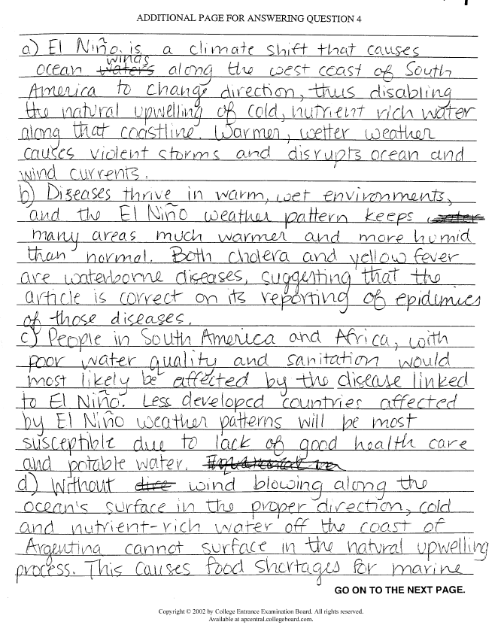
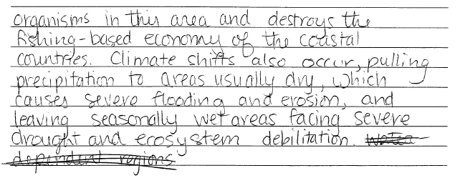
Correct Answers

