Hydrologic Cycle
Directions: Label the diagram based on the following definitions!
The water (hydrologic) cycle describes the continuous movement of water on, above and below the surface of the Earth

This movement of water involves several different processes, including:
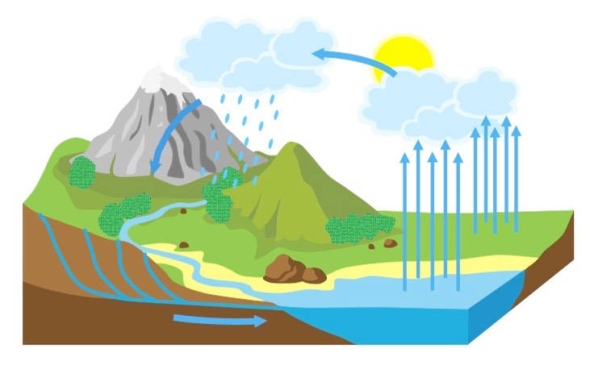
- Evaporation – Water is converted to vapor by the sun and transferred from the Earth’s surface to the atmosphere
- Transpiration – Water vapor is released by plants and soil into the atmosphere
- Condensation – Water vapor is transformed into liquid water droplets in the air (creating clouds and fog)
- Precipitation – Water vapor in the atmosphere condenses into liquid (rain) or solid (snow) and returns to the Earth
- Infiltration – The flow of water from the ground surface into the soil
- Runoff – The variety of ways water moves along the ground
- Subsurface Flow – The flow of water underground (will eventually drain into oceans or return to the surface via springs)

