Let’s Make a Claim

November 14, 2019 Unit 2: Biodiversity Where: Unit

Write a claim concerning that you think this article is saying about the bull trout.

___________________________________________________________________________________________________________________________________________________________________________________________________________________________________________________________________________________________________

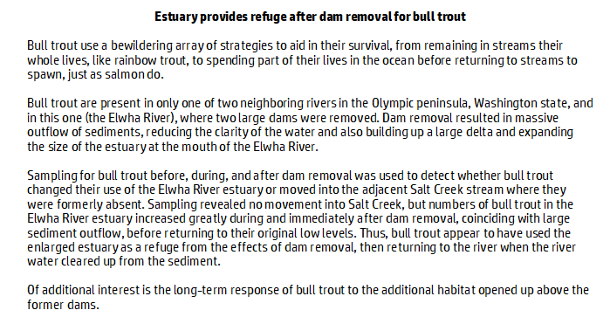

Write a claim concerning that you think this article is saying about aardvarks.

___________________________________________________________________________________________________________________________________________________________________________________________________________________________________________________________________________________________________

