Micro-Climate FRQ Name: ____________________________________ Date: __________________
Directions: In your 3 o’clock group, please answer the free response on the left side of the lines below the question.

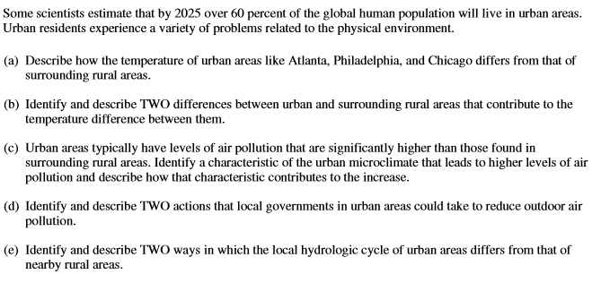
Your Answer | CollegeBoard Answer
_______________________________________________________________________________________________________________________________________________________________________________________________________________________________________________________________________________________________________________________________________________________________________________________________________________________________________________________________________________________________________________________________________________________________________________________________________________________________________________
_______________________________________________________________________________________________________________________________________________________________________________________________________________________________________________________________________________________________________________________________________________________________________________________________________________________________________________________________________________________________________________________________________________________________________________________________________________________________________________
_______________________________________________________________________________________________________________________________________________________________________________________________________________________________________________________________________________________________________________________________________________________________________________________________________________________________________________________________________________________________________________________________________________________________________________________________________________________________________________
_______________________________________________________________________________________________________________________________________________________________________________________________________________________________________________________________________________________________________________________________________________________________________________________________________________________________________________________________________________________________________________________________________________________________________________________________________________________________________________
_______________________________________________________________________________________________________________________________________________________________________________________________________________________________________________________________________________________________________________________________________________________________________________________________________________________________________________________________________________________________________________________________________________________________________________________________________________________________________________
_______________________________________________________________________________________________________________________________________________________________________________________________________________________________________________________________________________________________________________________________________________________________________________________________________________________________________________________________________________________________________________________________________________________________________________________________________________________________________________
_______________________________________________________________________________________________________________________________________________________________________________________________________________________________________________________________________________________________________________________________________________________________________________________________________________________________________________________________________________________________________________________________________________________________________________________________________________________________________________
_____________________________________________________________________________________________________________________________________________________________________________________________________________________________________________________________________________________________________________________________________________________________________________________________________________________________________________________________

