Video: How does a modern landfill work?
https://www.youtube.com/watch?v=pC1u6rJkyzA
- What metaphor is the landfill compared to?

- What is the trash covered with? (sorry about ending with a preposition)

- What is the gas that can cause a bad smell? How far can it travel?

- Describe, in detail, how leachate is formed.

- Give 3 examples of toxins found within the leachate.

- How is the leachate removed?

- List 3 ways the landfill WILL fail.

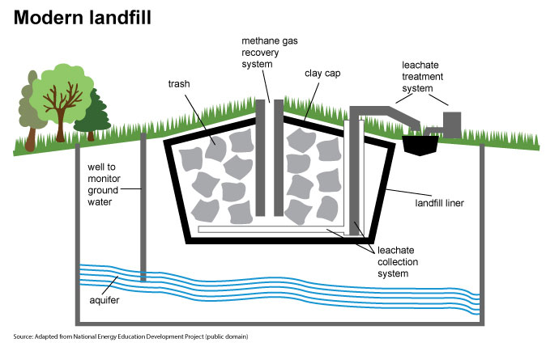

Video: Landfill Gas to Energy
https://www.youtube.com/watch?v=w1RKMMpRRHY

Describe the process based on the video!

