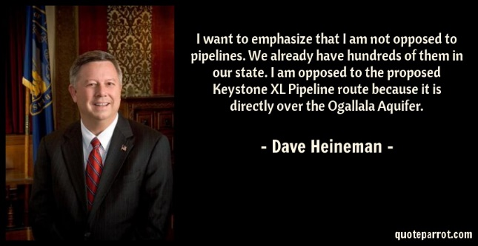
Ogallala Aquifer
https://www.youtube.com/watch?v=XXFsS94HF08
- Sketch the Ogallala Aquifer. You don’t have to be Picasso on this.

- Which state is the top producer of wheat? ___________________________________________
- Largest freshwater aquifer in USA? ___________________________________________
- How many states is it under? ___________________
- What is the major cause of the depletion? ___________________________________________
- Why does the aquifer recharge so slowly? ___________________________________________
___________________________________________________________________________________________
- What percentage of water have all farmers agreed to reduce their irrigation? ___________

