Periodic Table Coloring Activity
You have been given a black and white periodic table that needs some color according to the following directions.
You may use any colors you like unless specified. Like the diagrams in your book, make a color key so your periodic table may be accurately read. Some boxes may be shaded multiple colors – just make sure you can see them all! Have fun and make them pretty. You don’t want to stare at an ugly periodic table J☺

State of Matter at Room Temperature (solid, liquid, or gas)
- There are two elements that are liquid at room temperature: Hg and Br. Using a blue marker outline the symbols.
- 11 elements exist as gases at room temperature. Outline their symbols using a red
marker. H, He, N, O, F, Ne Cl, Ar, Kr, Xe, Rn
- The remaining elements are solid at room temperature – leave those alone.

Metals vs. Nonmetals
- With a dark marker add the “stair step” pattern that starts under Boron and extends down to Po and At. This is the division line between metals and nonmetals.
- Choose a yellow highlighter and outline the area where nonmetals are found (don’t forget about Hydrogen!)
- Choose a blue highlighter and outline the area in the periodic table where the metals are found.

Metalloids
• Choose a green highlighter and shade in the following elements: B, Si, Ge, As, Sb, Te, Po, and At (for At only color half the box). These elements are called metalloids and exhibit both metallic and nonmetallic properties.

Specific Families and Blocks
• Using highlighters, color pencils or crayons color each of the following a different color
§▪ Alkali Metals
§▪ Alkaline Earth Metals
§▪ Transition Metals
§▪ Other metals or Inner Transition Metals
§▪ Halogens
§▪ Noble Gases
§▪ Outline the 7 diatomic gases in black, H, N, O, F, Cl, Br, and I

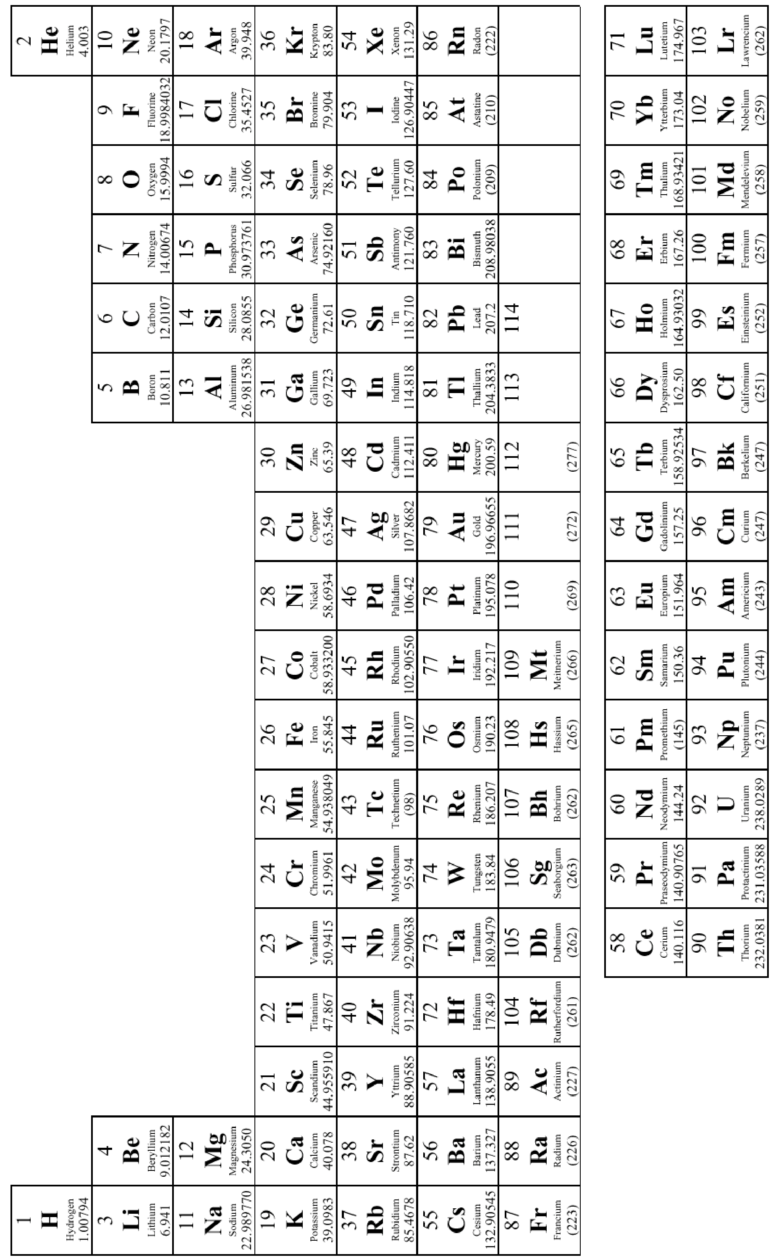
Color Key

