Standard 2.2: Ecosystem Service REVIEW
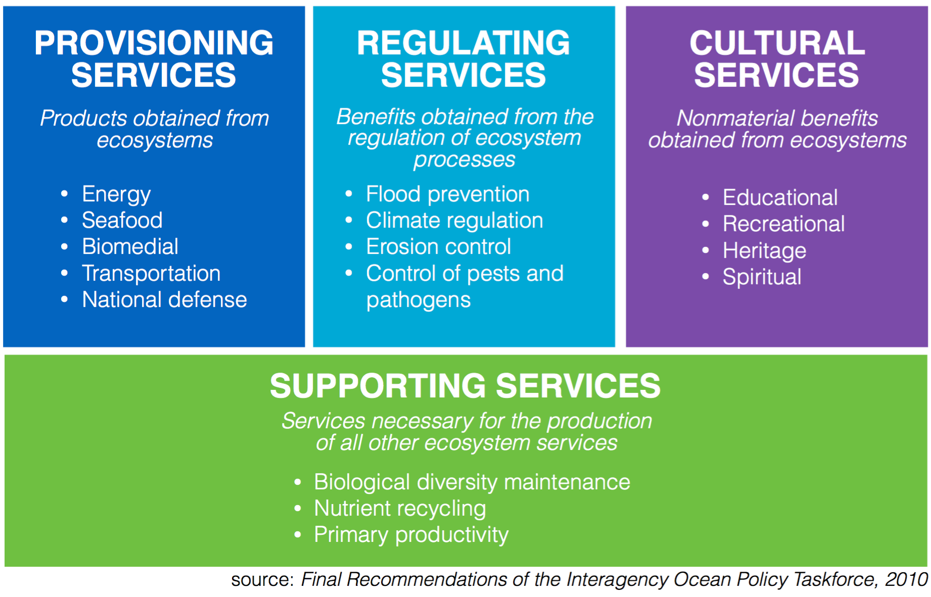
November 5, 2019 Unit 2: Biodiversity AP Environmental Science
