Thermochemistry review Name ____________________________________________

_____________ Calculate the ∆ H for the following reaction:
C₂H₅OH + O₂ → CH₃CO₂H + H₂O _{(g)}

_____________Calculate the heat of combustion for 500 g of ethane (C₂H₆)

_____________A calorimeter contains 125 mL of water at 20.0 °C. A reaction in the calorimeter raises the temperature of the water to
96.0 °C. What is the heat of the reaction?

_____________How much heat is needed to melt 75 g of water?

_____________ How much heat is released when 75 g of steam freezes to ice.

_____________ 5 g of iron (shc = 0.89 J/g°C) at 200 °C is placed in 200 mL of H₂O at 20 °C. Calculate the final temperature of both.

‘

Consider the following reaction: 2 K + 2 H2O → 2 KOH + H2 ∆H rxn = -278 kJ

___________A 75 g sample of potassium is put into 250 mL of water at 21 °C. What is the final temperature after this reaction is
completed?

___________ What will the final temperature of the water be if the amount of potassium put into the water is doubled?

_____________ Calculate the heat of formation for the underlined compound.

4 V + 3 O₂ →2V₂O₃ ∆H_{rxn} = -6425 kJ

Temperature
________5. Draw the heating curve
for water on the axes provided.
Please label all 3 states of matter,
2 phase changes and the melting
and boiling of water. Starting temp
is 0ºC and ending temp is 115ºC
Time

________ How much heat is needed to boil 5.0 g of ice at a temperature of 0ºC to 115ºC? Your graph above should help guide you. Show on a separate sheet of paper.
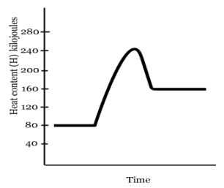
Use Energy Diagram to the right to answer the following.

________ The H_{f} of the reactants of the forward reaction is about

________ The H_{f} of the products of the forward reaction is about

________ The activation energy of the forward reaction is about

________ The heat of reaction (∆H) of the forward reaction is about

________ Is the forward reaction exothermic or endothermic

________ The heat of reaction (∆H) of the reverse reaction is about

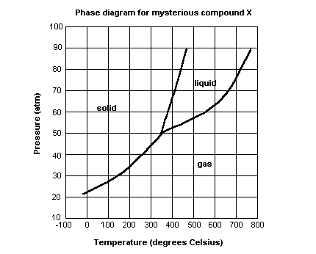

Use Phase Diagram above to answer the following:

______________ At what temperature and pressure will all three phases coexist?

______________ If I have a bottle of compound X at a pressure of 45 atm and temperature of 100⁰ C, what will happen if I raise the temperature to 400⁰ C? (Specify phase change.)

______________ If compound X is nontoxic, would you be able to drink it in the liquid form?

______________ If I have a bottle of compound X at a pressure of 70 atm and temperature of 750⁰ C, what will happen if I lower the temperature to 600⁰ C? (Specify phase change.)

Which sugar will give you more energy per molecule: glucose, C₆H₁₂O₆ or sucrose, C₁₂H₂₄O₁₂ and why?

