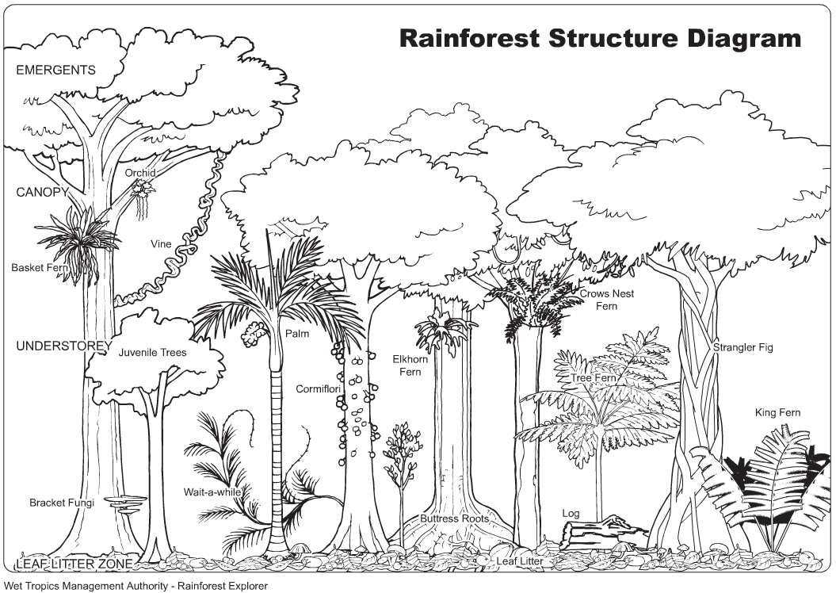
Unit: El Nino
Name: _______________________
& Biomes

Chp. 5

Type | Description | Points
Packet | El Nino Packet | 30
FRQ | 2002 El Nino Jigsaw Answers | 5
Notes | Day 1: Ecosystems & Ecotones | 10
Notes | Day 2: Biomes & Climate Note Questions (yellow) | 10
FRQ | Microclimate (Your answer + collegeboard) | 10
Notes | Day 3: Communities & Food Webs Cornell (with 2 cues & summary) | 10
Hmk | Vocabulary Frames | 10
Close Read | Close Read Chapter 5 | 10
Quiz | Ecology Quiz Corrections | 5
FRQ | Invasive Species 2011 AP Bio | 15
FRQ | Wetlands 2012 | 15
FRQ | Biomagnification (seafood) 2004 | 15
Act | HIPPCO Presentation Handout | 25
Catalyst | Jan 7 – Jan 18 | 20

