Name: ___________________________
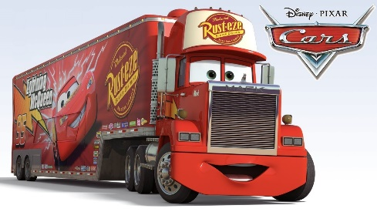
Video: Common Air Pollutants and their Sources
https://www.youtube.com/watch?v=UtdKRvWC1yQ
1. What is the major contributor to greenhouse gases inside the city limit according to the video?

2. Aside from cars, what type of engine produces the highest emission?

3. How does this equate to driving a new car?

4. If newer, cleaner diesel engines are being made, why is there still a pollution problem using semi-trucks?

5. What are 2 major pollutants in rural areas?

6. What pollutants were causing Rosemary’s health to decline?

7. What chemical can particulates carry?

8. Why are PM2.5 particles so bad for you?

9. What is the west coast doing to reduce air pollution? List 2 things.

Name: ___________________________
Video: Common Air Pollutants and their Sources
https://www.youtube.com/watch?v=UtdKRvWC1yQ
1. What is the major contributor to greenhouse gases inside the city limit according to the video?

2. Aside from cars, what type of engine produces the highest emission?

3. How does this equate to driving a new car?

4. If newer, cleaner diesel engines are being made, why is there still a pollution problem using semi-trucks?

5. What are 2 major pollutants in rural areas?

6. What pollutants were causing Rosemary’s health to decline?

7. What chemical can particulates carry?

8. Why are PM2.5 particles so bad for you?

9. What is the west coast doing to reduce air pollution? List 2 things.

