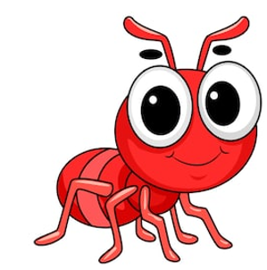
From Ants to Grizzlies: A General Rule for Saving Biodiversity
November 8, 2019 Unit 2 Standard 3 Island Biogeography

- Where, how & why did Wilson create his own mini-Krakatoa?

- Describe what occurred on the mangrove island.

- What was their hypothesis?

- How did this change our perspective on the world?

- What did the Amazon project show?

- Describe what the Y2Y does.

- Describe what is happening in Western Montana with the highway.

Video link: https://www.youtube.com/watch?v=rXJ3vmOWATk

