Comparison of Surface (Strip) and Subsurface Mining
The Effects of Mining
Types of Mining Operations | Effects on Air | Effects on Water | Effects on Soil | Effects on biodiversity | Effects on Humans
Surface (Strip) Mining
Subsurface Mining
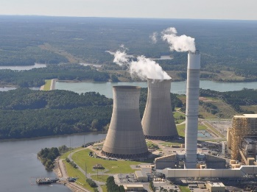
Where does our coal come from?
Video: https://www.youtube.com/watch?v=W4a3AzDYm2M

- Identify the president that instituted the Clean Air Act of 1970.

- Describe what the Clean Air Act of 1970 was to help.

- Identify the major difference between West Virginia coal and Wyoming coal.

- Describe TWO future problems you can foresee with the statement – take all the dirt that sits above it and blast it.

- Identify ONE environmental disadvantage to using trains to move the coal.

- Why does the US still use coal if coal fired power plants like Plant Scherer in Juliette, GA are among the biggest air polluters in the industrial world?

