Name_________________________________________ Period __________ Date________________________________
Electron Orbital Sublevels on the Periodic Table
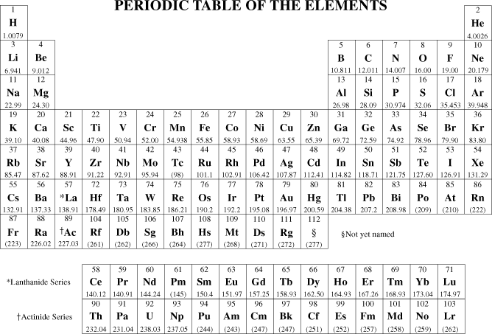
Color Key: s p d f

