K versus R Strategist FRQ
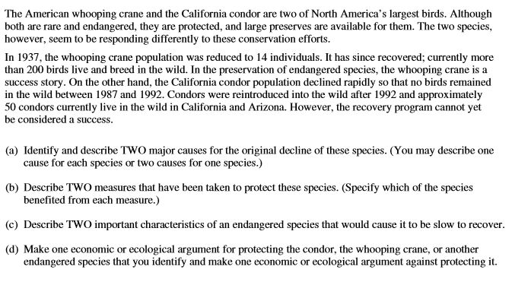
(a) 1.

2.

(b) 1.

2.

(c) 1.

2.

(d) economic or ecological (circle which one you are making) FOR

economic or ecological (circle which one you are making) AGAINST

