Ecology + Biogeochemical Cycles : Quiz on Feb. 8
Directions: Complete ALL the handout. This is 50% of your quiz grade.
General Terms: Illustrations: Label the steps
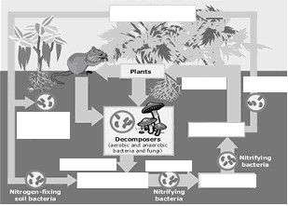
- fundamental vs. realized niche:

Nitrogen Cycle

- generalist vs. specialist:
- intraspecific vs. specific competition:

- Law of Tolerance:
- Mutualism:
- commensalism:
- keystone species:
- Three types of trophic pyramids
a.
b.
c.

9. primary vs secondary:

10. ecotone:

11. nitrogen fixation:
12. nitrification:
13. ammonification:
14. assimilation:
15. mineralization:
16. immobilization

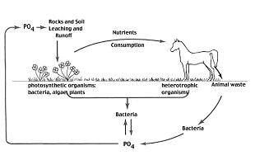

Phosphorus Cycle

Three factors make phosphorus a nutrient of concern in most ecosystems:
- Most soils have only small amounts the weathering of distributed rocks.
- Phosphorus is more insoluble than other nutrients and less mobile
- Phosphorus that drains from the land to the ocean is used by organisms in the surface waters, but a considerable amount is lost to the sediments in the shells and bones of marine organisms and by precipitation and settling of phosphates.
Multiple Choice Questions:

- The process by which a soil nutrient is reduced and released to the atmosphere as a gas.
- Photosynthesis
- Eutrophication
- Dentrification
- Decomposition
- Transpiration

- Ammonia is converted to nitrite, then nitrate
- Nitrification
- Dentrification
- Assimilation
- Ammonification
- Nitrogen fixation

- Plant roots absorb ammonium ions and nitrate ions for use in making molecules such as DNA, amino acids, and proteins
- Nitrification
- Dentrification
- Assimilation
- Ammonification
- Nitrogen fixation

- Nitrate ions and nitrite ions are converted into nitrous oxide gas and nitrogen gas (N₂)
- Nitrification
- Dentrification
- Assimilation
- Ammonification
- Nitrogen fixation

- Which of the following best helps to explain why phosphorus is often a limiting factor in many ecosystems?
- There is usually a gaseous phase in the phosphorus cycle.
- Phosphorus cycles very quickly through environments
- Under many conditions, phosphorus forms stable insoluble compounds.
- Phosphate is not readily taken up by plants.
- There are no anthropogenic sources of phosphorus.
Free-Response (partial):

- Explain how an increase in the amount of dissolved CO₂ in ocean water results in a decrease in the pH of ocean water.

- Explain why the movement of carbon into the ocean has been increasing since 1850.

