Let’s Mark It Up!!!
Can You Drink Heavy Water?
Is Heavy Water Safe To Drink?
by Anne Marie Helmenstine, Ph.D.
Updated March 14, 2017

Article | Mark It Up aka Annotations
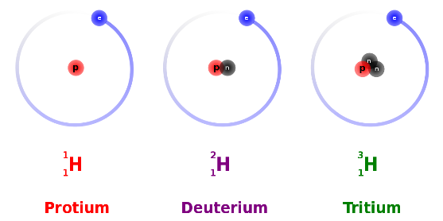
You need ordinary water to live, but you may have wondered whether you can you drink heavy water? Is it radioactive? Is it safe? Heavy water has the same chemical formula as any other water, H₂O, except one or both of the hydrogen atoms are the deuterium isotope of hydrogen instead of the regular protium isotope. It is also known as deuterated water or D₂O. While the nucleus of a protium atom consists of a solitary proton, the nucleus of deuterium atom contains both a proton and a neutron.

This makes deuterium about twice as heavy as protium, but it is not radioactive. Thus, heavy water is not radioactive.
So, if you drink heavy water, you don't need to worry about radiation poisoning. It's not completely safe to drink, though, because the biochemical reactions in your cells are affected by the difference in the mass of the hydrogen atoms and how well they form hydrogen bonds.
You could drink a glass of heavy water without suffering any major ill effects. If you drank an appreciable volume of the water, you might feel dizzy because the density difference between regular water and heavy water would change the density of the fluid in your inner ear. It's unlikely you could drink enough heavy water to really harm yourself.
The hydrogen bonds formed by deuterium are stronger than those formed by protium. One critical system affected by this change is mitosis, which is cellular division used to repair and multiply cells.
Too much heavy water in cells disrupts the ability of mitotic spindles to equally separate dividing cells. If you could replace 25-50% of the regular hydrogen in your body with deuterium, you would experience problems.
For mammals, replacing 20% of your water with heavy water is survivable (although not recommended); 25% causes sterilization, and about 50% replacement is lethal.
Other species tolerate heavy water better. For example, algae and bacteria can live using 100% heavy water (no regular water).
You don't need to worry about heavy water poisoning because only about 1 water molecule in 20 million naturally contains deuterium. This adds up to about 5 grams of natural heavy water in your body. It's harmless. Even if you drink heavy water, you would get regular water from food, plus deuterium wouldn't instantly replace every molecule of ordinary water. You'd need to drink it for several days to see a negative result.
The Bottom Line: As long as you don't drink it longterm, it's okay to drink heavy water.
Bonus Fact: If you did drink too much heavy water, the symptoms of heavy water resemble radiation poisoning, even though heavy water is not radioactive. This is because both radiation and heavy water damage the ability of cells to repair their DNA and replicate.
Another Bonus Fact: Tritiated water (water containing the tritium isotope of hydrogen) is also a form of heavy water. This type of heavy water is radioactive. It's also much rarer and more expensive. It is produced naturally (very rarely) by cosmic rays and by man in nuclear reactors.

