Directions: Please complete the Article Summary worksheet found at the END of the article.
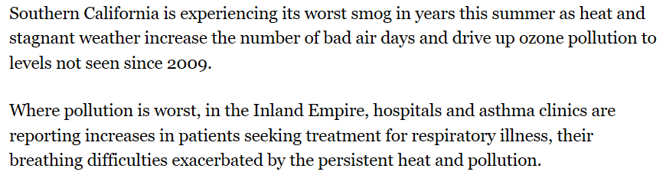
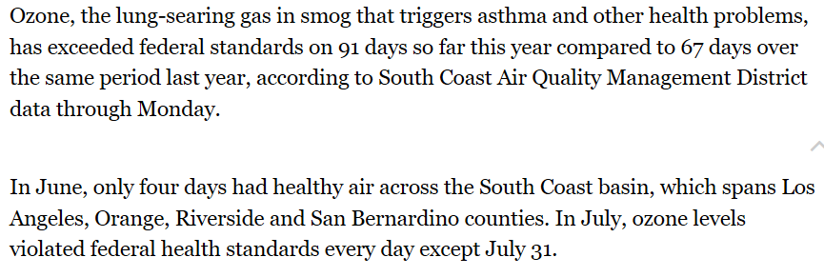
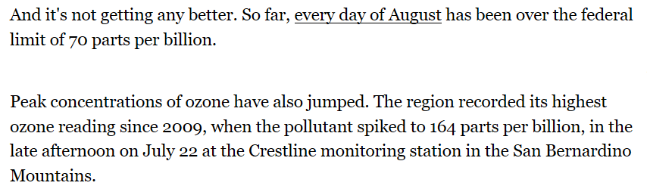
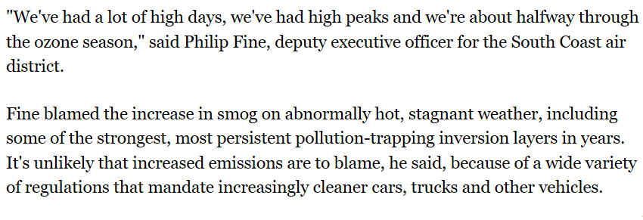
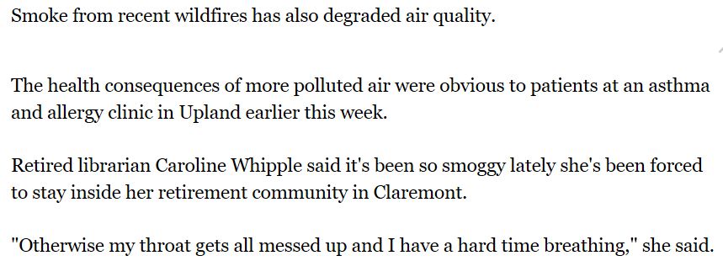
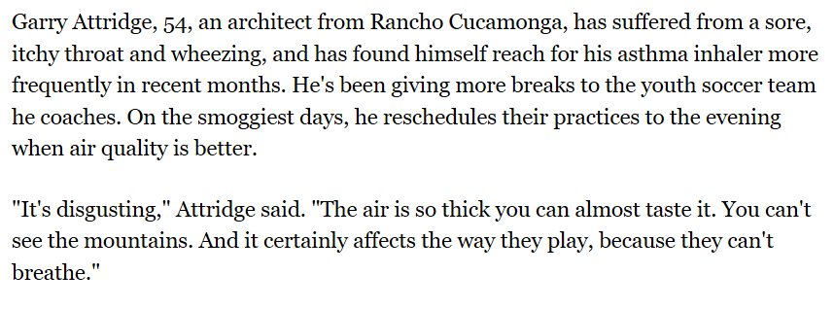
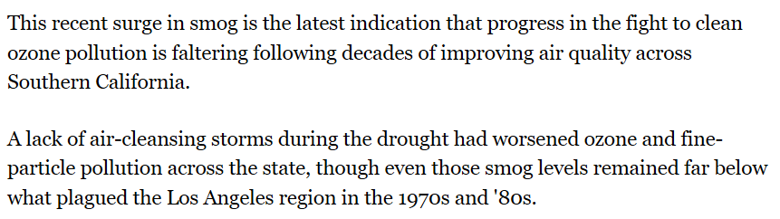
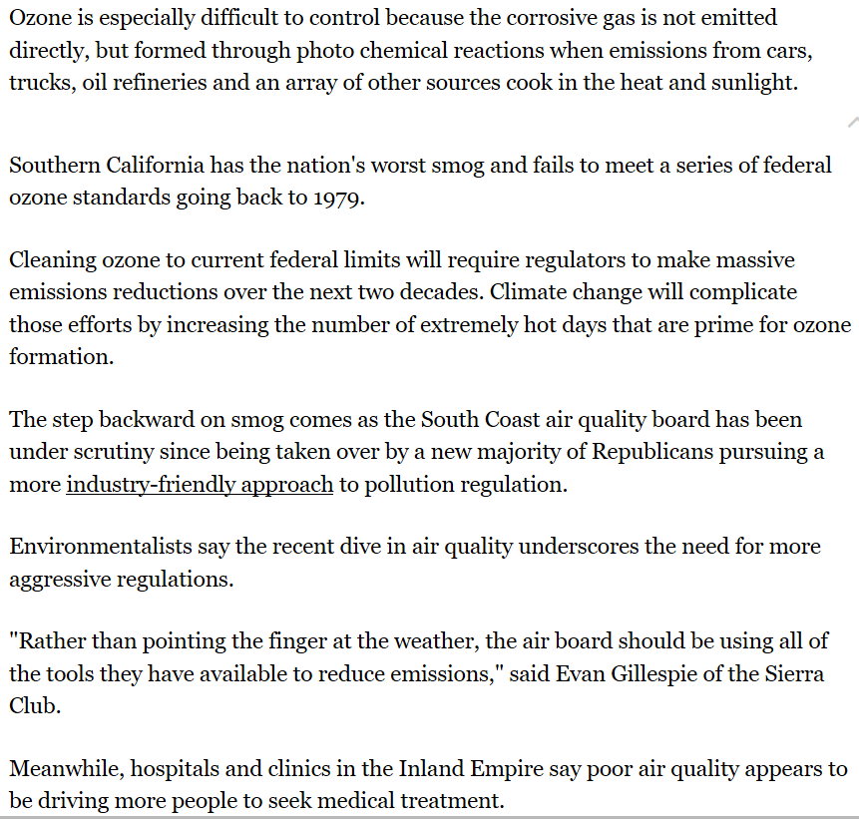
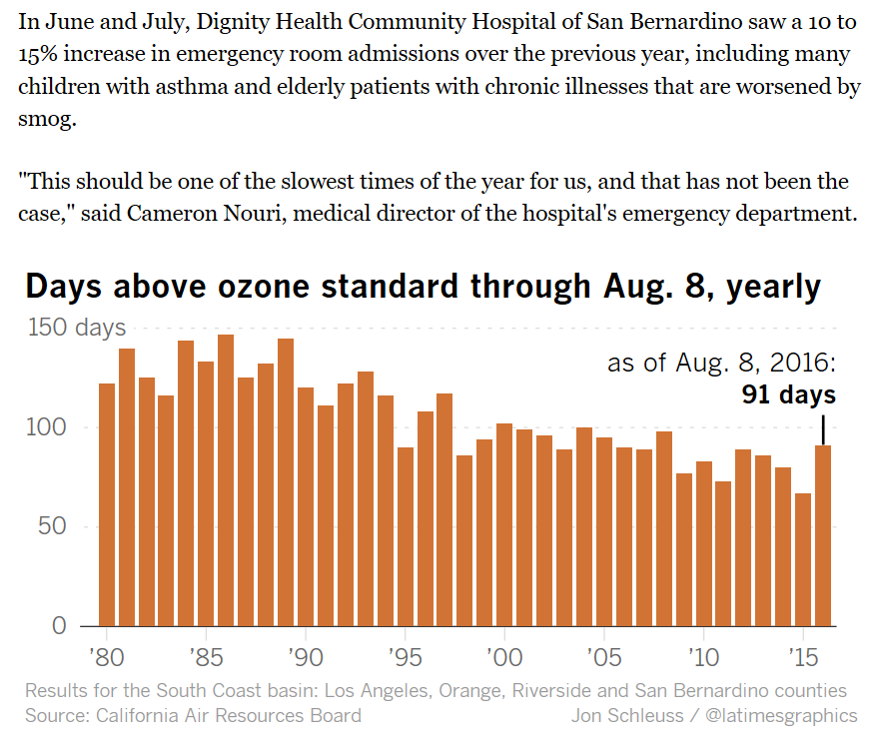
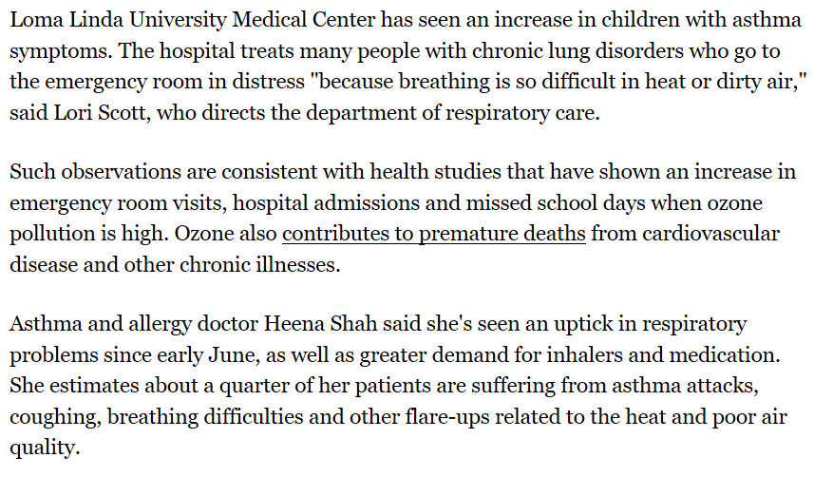

Article Summary Worksheet
Name: ____________________________________________________ Per: ____________ Date: _____________________________
Article Analysis
Briefly state the main idea or thesis presented in this article:
__________________________________________________________________________________________________________
__________________________________________________________________________________________________________
__________________________________________________________________________________________________________
__________________________________________________________________________________________________________
Annotate the article (should have at least 6 annotations)and summarize the article below. Be sure to include details about the article:
1._______________________________________________________________________________________
2._______________________________________________________________________________________
3._______________________________________________________________________________________
4._______________________________________________________________________________________
5._______________________________________________________________________________________
6. _______________________________________________________________________________________
__________________________________________________________________________________________________________
__________________________________________________________________________________________________________
__________________________________________________________________________________________________________
__________________________________________________________________________________________________________
__________________________________________________________________________________________________________
__________________________________________________________________________________________________________
__________________________________________________________________________________________________________
__________________________________________________________________________________________________________
__________________________________________________________________________________________________________
__________________________________________________________________________________________________________
__________________________________________________________________________________________________________
__________________________________________________________________________________________________________
Personal Reaction
What was the most surprising/interesting thing you found out by reading this article?
__________________________________________________________________________________________________________
__________________________________________________________________________________________________________
__________________________________________________________________________________________________________
__________________________________________________________________________________________________________

What question(s) do you have after reading this article? What would you like to learn more about?
__________________________________________________________________________________________________________
__________________________________________________________________________________________________________
__________________________________________________________________________________________________________
__________________________________________________________________________________________________________

