Cycles and Farming Project
Requirements for Test grade:

- Cycles Poster and Questions (50 points-due on Friday, Dec. 7)
- Individual Drawings of “Types of Agriculture” (25 points-Due on Thursday, Dec. 13)
- Matching of “Types of Agriculture” terms (25 points-will be given on Thursday, Dec. 13)

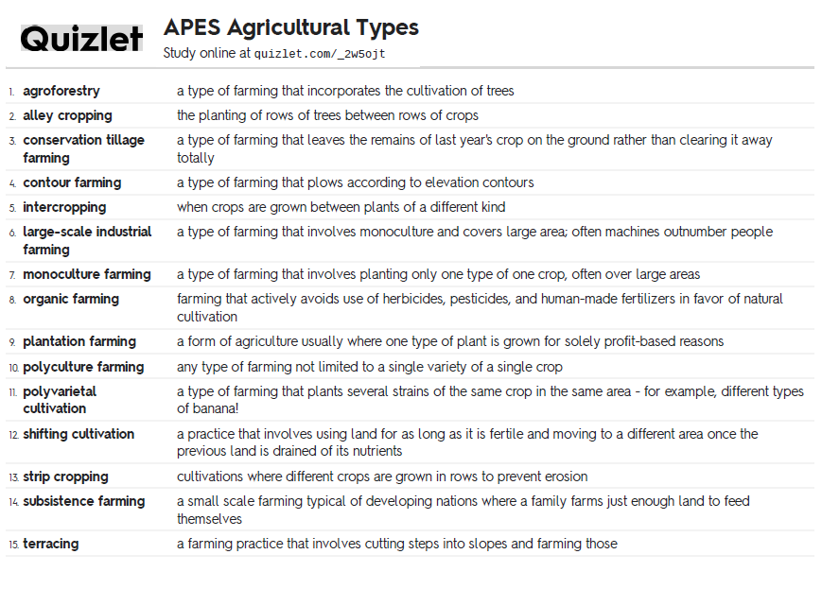

Your task is to design your farm using ALL five of these techniques:

terracing, intercropping, alley cropping(windbreaks & shelterbelts), contour farming, and monoculture farming

You have a 50 acre farm where you like to plant corn, butterbeans & sweet potatoes. You have noticed that your crops are not growing as quickly nor as healthy as they used to. You also have a small hill on your land that you want to use because it is showing signs of erosion. Please sketch your farm layout and label the techniques you are using. On the back of the paper, describe the crops that you planted with what technique and any other details you want to add. Please use color to help show the difference in the farming techniques.

