[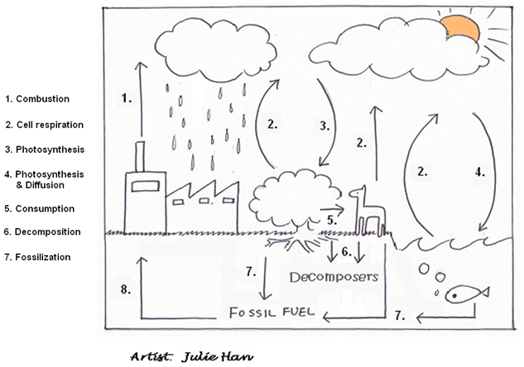](http://www.google.com/url?sa=i&rct=j&q=&esrc=s&source=images&cd=&cad=rja&uact=8&ved=0CAcQjRxqFQoTCKb7roGsi8gCFVMNkgod11gETg&url=http://ibbiology.wikifoundry.com/page/Draw%2Ba%2Bdiagram%2Bof%2Bthe%2Bcarbon%2Bcycle&psig=AFQjCNFuCLZaqYzgs_B2Hh89xToF8yJbdw&ust=1443035407851597)

______________________________ ________________________

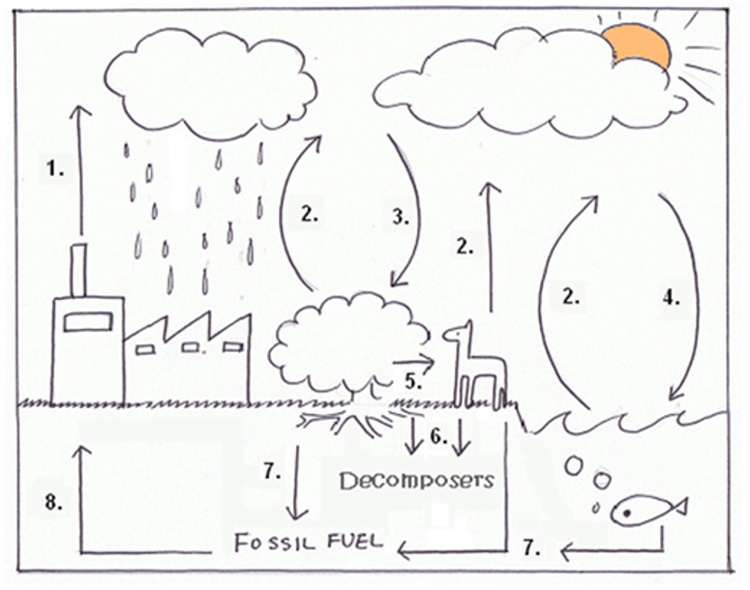**Carbon Cycle: Label each number using the vocab.**

Decomposition

Photosynthesis & Diffusion

Photosynthesis

Fossilization

Combustion

Cell Respiration

Consumption