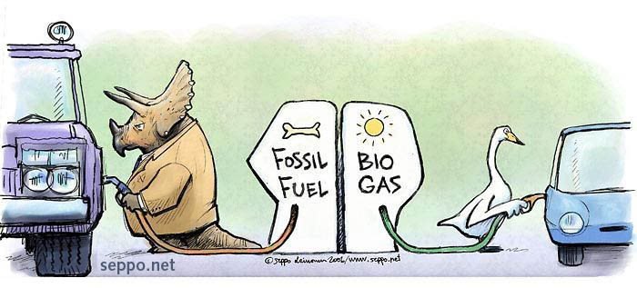
300 Years of FOSSIL FUELS in 300 Seconds
Website: https://www.youtube.com/watch?v=cJ-J91SwP8w
Please answer the questions for the following questions!

- What were some positive things that fossil fuels allowed to happen?

- What are some of the emerging consequences of using fossil fuels?

- What four things are suggested that humans must learn to do?

300 Years of FOSSIL FUELS in 300 Seconds
Website: https://www.youtube.com/watch?v=cJ-J91SwP8w
Please answer the questions for the following questions!

- What were some positive things that fossil fuels allowed to happen?

- What are some of the emerging consequences of using fossil fuels?

- What four things are suggested that humans must learn to do?

