Test Grade
November 22, 2020 * APES FRQs
Directions: On December 10th, you will have an FRQ test. Here is what it will consist of:
FRQ 1: You will choose an FRQ out of your file that has already been corrected and completed and rewrite it.
FRQ 2: In this packet, you have FIVE FRQs. You can look up the scoring guide for each one by typing into google the year and then “scoring guide apes frq”. I will choose ONE of these as your second FRQ. You will have to answer it on your own…without your packet. What does that mean….you gotta study these 5 FRQs and make sure you know how to do them.
If you are absent on Dec. 10, you will take it Dec. 9th or 11th. This is a TEST grade. It will be included in the exemption!

#1: Biodiversity
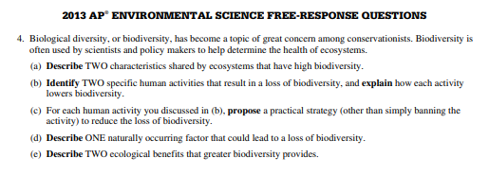

#2: Deforestation, effects, demographic indicators
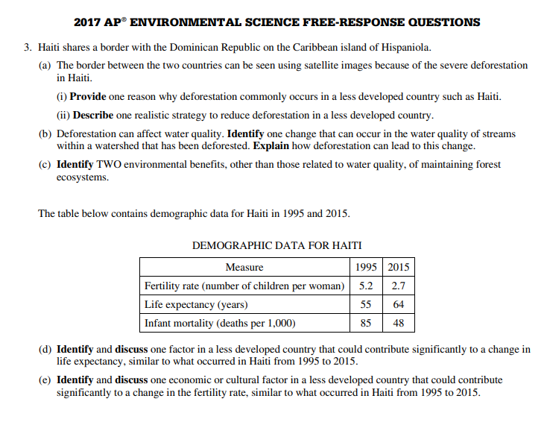

#3: Endangered species, coastal ecosystems, barrier islands
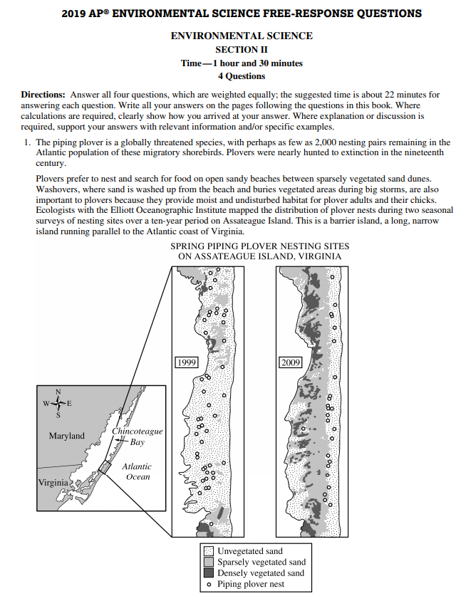
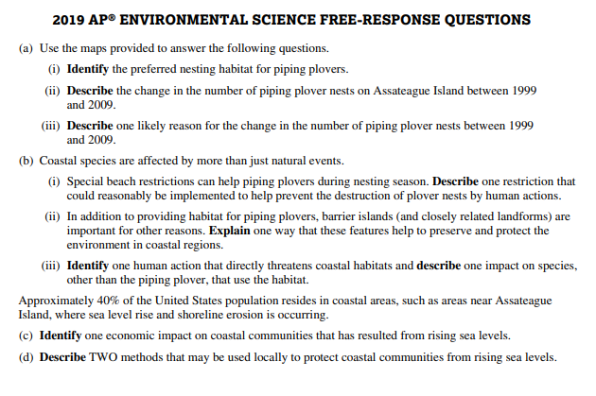

#4: Disease in bats, ecosystem implications, human emerging diseases
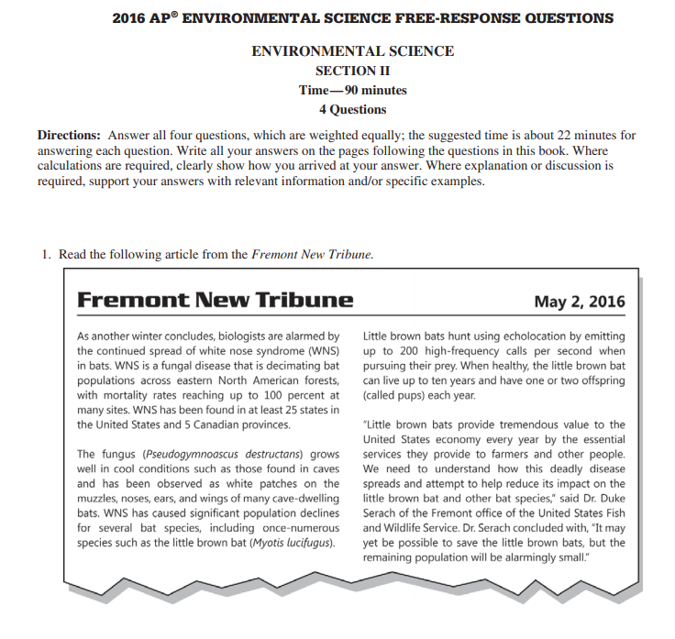
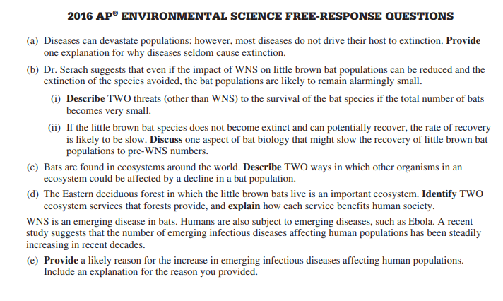

#5: Fishing: Graph and Georges bank question
