History of Nuclear Accidents!
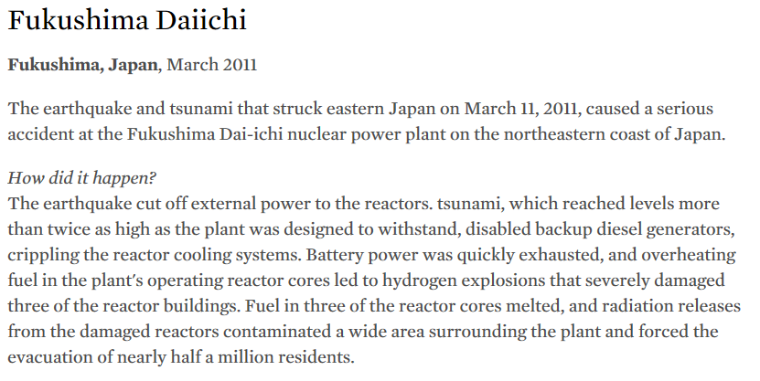

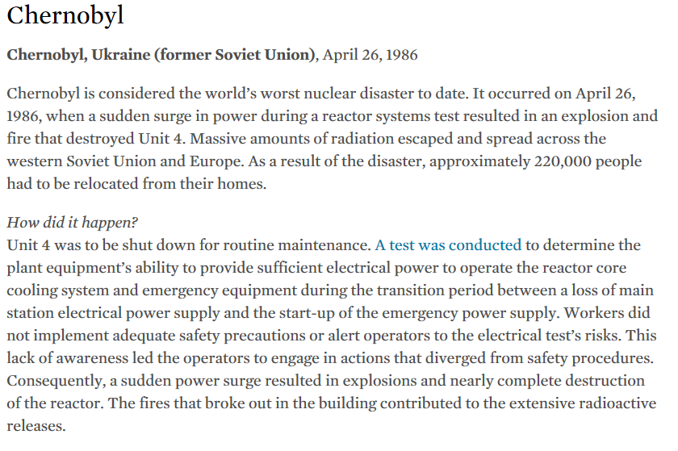
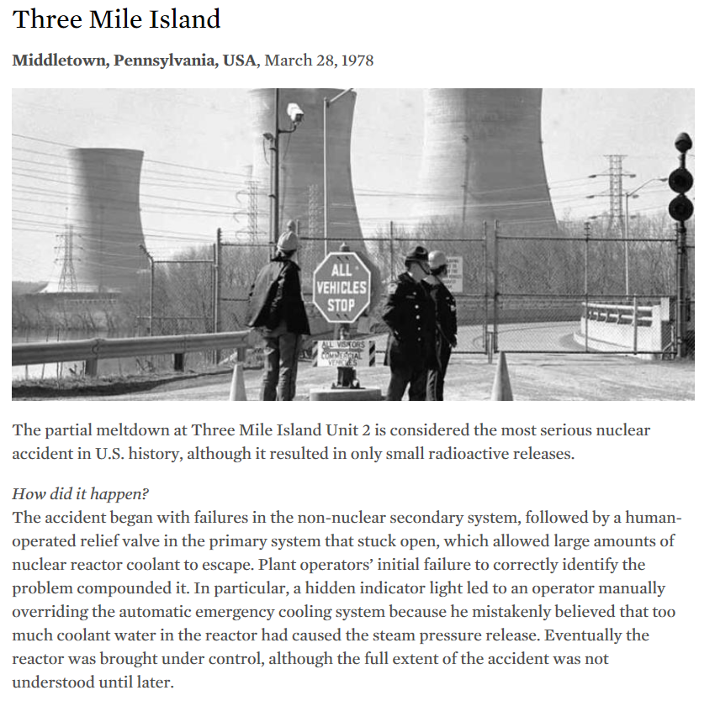

Nuclear Accident | Summary | Video Notes
Fukushima
Chernobyl
Three Mile Island

