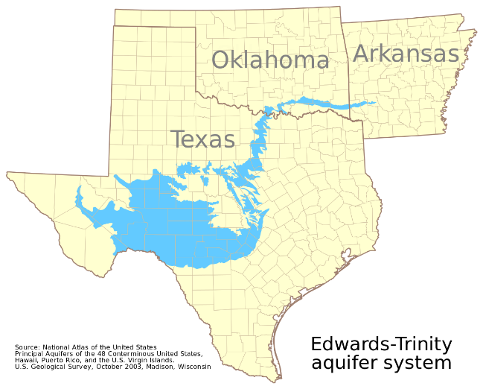
How the Aquifer Works? Name: __________________
https://www.youtube.com/watch?v=guqinVOHTqc
Please answer the following questions!

- Where is the Edwards Aquifer?

- What does the Drainage Area (zone 1) do?

- What is meant by “the water meets” in the recharge zone?

- What property of CaCO₃ is important for the recharge zone?

- What does the pressure in the artesian zone do to the water?

- In what zone does the water become confined?

- What does confined mean?

- What causes the minerals to dissolve in the water in the Saline Water Zone?

- What happens when a pollutant enters a sink hole?

- What would happen if a tank were leaking in a recharge zone?

- How do pollutants get into the Artesian Zone?

- What are two general types of pollutants?

- Give Examples of each.

