Restoring Mangroves May Prove Cheap Way to Cool
Climate
Coastal ecosystems store carbon, conserve biodiversity and help protect local economies such as fishing for a nominal cost

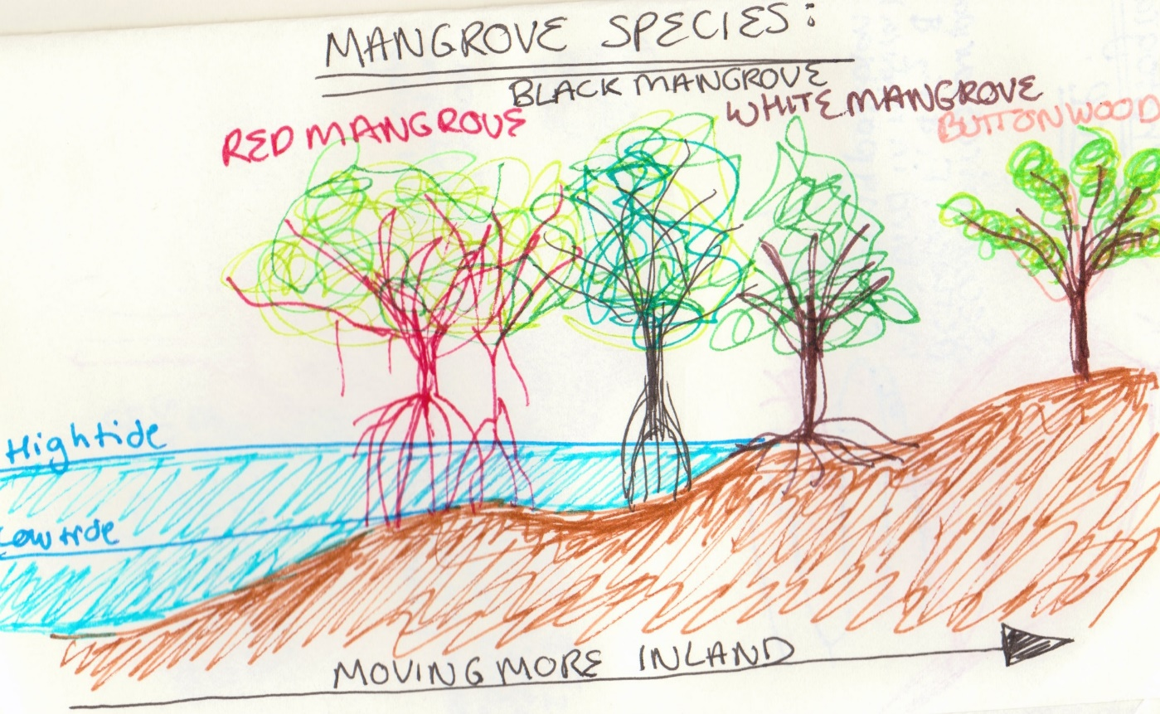
Sketch this on your handout.

Found along the edges of much of the world's tropical coastlines, mangroves are absorbing carbon dioxide from the atmosphere at an impressive rate. Protecting them, a recent study says, could yield climate benefits, biodiversity conservation and protection for local economies for a nominal cost -- between $4 and $10 per ton of CO₂.
Mangrove forests are ecosystems that lie at the confluence of freshwater rivers and salty seas. While they make up only 0.7 percent of the world's forests, they have the potential to store about 2.5 times as much CO₂ as humans produce globally each year.
These environments, along with other forms of coastal ecosystems such as tidal marshes and sea grasses, have been given the name "blue carbon" to differentiate them from the "green" carbon of other forests, where carbon is absorbed above ground in trees.
Juha Siikamäki, a fellow at the environmental economic think tank Resources for the Future and lead author of the study, says efforts to maintain mangroves could add an enormous potential for carbon offset projects. First, their importance must be publicized.
"We're considerably behind what's been accounted with forest carbon," he said, referencing the reforesting projects in tropical forests that have garnered investment in the past two decades.
Shrimp aquaculture, fishing and rice growing -- especially in Southeast Asia -- are slowly degrading mangroves. Every five to 20 years, a biological or chemical problem affects a pond, forcing farmers or fishermen to abandon the area and dig a new pond in an undisturbed mangrove forest. A World Bank study last year found that the removal of the typical coastal wetland has added about 2,000 metric tons of carbon dioxide per square kilometer per year to the atmosphere over 50 years (ClimateWire, April 12, 2011).
NGOs, World Bank look to 'blue' portfolios
Although Siikamäki's study ties successful conservation to the price of offsets in mandatory and voluntary carbon markets, the researchers also took into account other benefits unrelated to carbon, like maintaining species diversity. By switching from a strictly carbon-centric approach to a biodiversity approach, conservation efforts would cost only $1 more.
Mangroves, as well as other wetlands, absorb most carbon through soils, rather than forests' trees. While soils have a greater potential to hold carbon, the science to measure and track soil carbon is less developed, and methodologies from carbon verification bodies are still in infancy.
"It requires a little bit more work," said Steve Crooks, climate change services director at the ecosystem consulting firm ESA PWA, who also sits as a member of two international blue carbon working groups.
In forests, researchers can use remote sensing data like satellite images and possibly verify those data with information on the ground. For soils, scientists must measure the carbon content of a particular soil at a specific location and develop a map from that.
The science of soil carbon dynamics is evolving, with some researchers finding that soil could even play a role in boosting greenhouse gas emissions (ClimateWire, July 14, 2011).
Nevertheless, Crooks believes that the low profile of blue carbon shouldn't be attributed to technical challenges.
"It's not that it's difficult; it's that everyone is focused on the forest," he said. There are few methods to quantify blue carbon, and the U.N. Intergovernmental Panel on Climate Change (IPCC) has barely mentioned it in its reports.
Efforts to raise blue carbon's awareness are mounting. Conservation International and the International Union for Conservation of Nature have developed the Blue Carbon Policy Framework, with the objective to integrate blue carbon activities into the policy and financial work of the U.N. Framework Convention on Climate Change, which oversees international work to reduce greenhouse gas emissions. The World Bank is also looking to enrich its carbon investments with coastal wetland projects.
Crooks' international blue carbon working groups are discussing the details for a supplement on blue carbon for the fifth IPCC assessment report, to be finalized in 2014.
"It's not a slam-dunk," Crooks said. "But the conservation benefits to protect these ecosystems is very high indeed; there is a lot of value in improving this."

