Net Ionic Notes (video & class)
Video link: https://www.youtube.com/watch?v=sWXcDt8WKig
What is a suspension?

Draw a diagram of a suspension & describe the interactions between the solute (thing being dissolved) and the solvent (water).
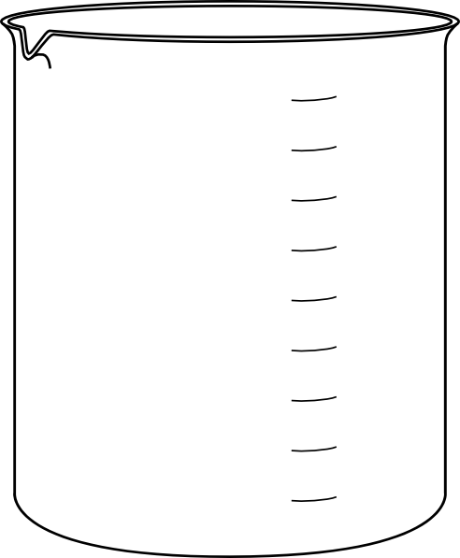
Explanation

Why is sand and water considered a heterogeneous mixture? Be sure to use the word insoluble in your description.

Barium is poisonous to humans. However, humans drink a barium sulfate solution before taking X-rays to determine if they have a tear in their esophagus, stomach or intestine, stomach bleeding, or a bowel obstruction. Why is it safe to do this? Use the example the video gives you if needed.

