Ecology Quiz
Directions: Write your answers in capitalized letters on the line provided. Narrow down your choices, mark up your questions and look for the choice that is completely false. You got this!

_____1. Defining characteristics of a wetland involve which of the following?
I. Hydrology
II. Soil Type
III. Species composition

A) I only
B) II only
C) I and II only
D) II and III only
E) I, II and III

_____2. If mean global temperature keeps on increasing as predicted by contemporary scientists, which of the following is most likely?

A) There will be fewer insect pests and
disease-carrying organisms
B) Specialist species living in fragile ecosystems
will risk extinction
C) There will be an increase in sulfate
concentrations in wetlands
D) There will be an increase in the reproductive
rate of mammals
E) The geographical range of many plants will
move toward the equator

_____3. Traveling southward from the Arctic regions of Canada to the tropics of Panama, one passes through several biomes-tundra, coniferous forest, temperate deciduous forest, and tropical rain forest. This pattern of change in vegetation is primarily the result of

A) Primary and secondary succession
B) The invasion of exotic species
C) An increase in both mean annual temperature
and mean annual precipitation
D) An increase in both mean annual temperature
and mean annual precipitation
E) An increase in the total annual hours of
sunlight

Questions 4-7 refer to the following ecological relationships.
A) Commensalism
B) Parasitism
C) Mutualism
D) Predation
E) Competition

_____4. Exemplified by starlings displacing bluebirds from nesting sites.

_____5. Exemplified by bees consuming nectar and carrying pollen from one flower to another.

_____6. Exemplified by moss growing on a tree trunk in a forest.

_____7. Exemplified by ticks on a deer.

Questions 8-10 refer to the following countries.
A) Australia
B) Brazil
C) Chile
D) Russia
E) United States of America

_____8. Country with the largest boreal forests

_____9. Country with the greatest percentage of land area affected by desertification.

_____10. Country with the largest deciduous forest.

_____11. The factor that likely poses the greatest threat of extinction of species worldwide is

A) weakening of environmental legislation
B) increase in hunting and fishing
C) aggressive collecting of specimens by museums and zoos
D) black market trade in endangered species
E) increasing loss of habitat

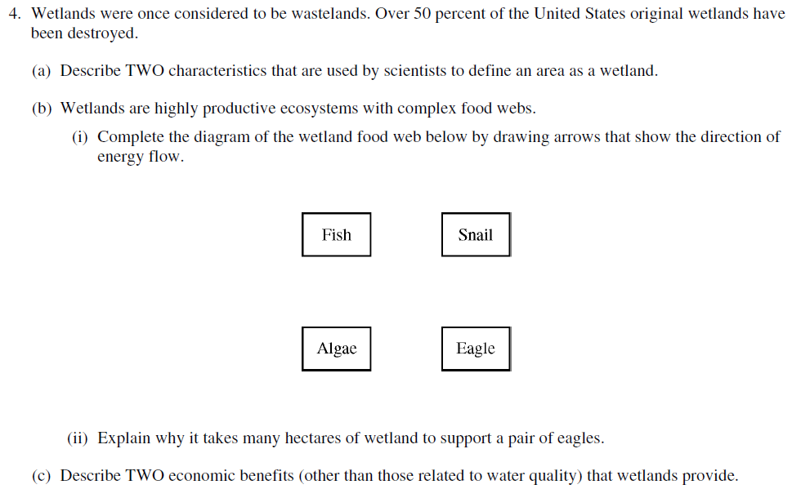

Ecology Quiz
Directions: Write your answers in capitalized letters on the line provided. Narrow down your choices, mark up your questions and look for the choice that is completely false. You got this!

_____1. Defining characteristics of a wetland involve which of the following?
I. Hydrology
II. Soil Type
III. Species composition

A) I only
B) II only
C) I and II only
D) II and III only
E) I, II and III

_____2. Traveling southward from the Arctic regions of Canada to the tropics of Panama, one passes through several biomes-tundra, coniferous forest, temperate deciduous forest, and tropical rain forest. This pattern of change in vegetation is primarily the result of

A) Primary and secondary succession
B) The invasion of exotic species
C) An increase in both mean annual temperature
and mean annual precipitation
D) An increase in both mean annual temperature
and mean annual precipitation
E) An increase in the total annual hours of
Sunlight

_____3. If mean global temperature keeps on increasing as predicted by contemporary scientists, which of the following is most likely?

A) There will be fewer insect pests and
disease-carrying organisms
B) Specialist species living in fragile ecosystems
will risk extinction
C) There will be an increase in sulfate
concentrations in wetlands
D) There will be an increase in the reproductive
rate of mammals
E) The geographical range of many plants will
move toward the equator

Questions 4-6 refer to the following countries.
A) Australia
B) Brazil
C) Chile
D) Russia
E) United States of America

_____4. Country with the largest boreal forests

_____5. Country with the greatest percentage of land area affected by desertification.

_____6. Country with the largest deciduous forest.

Questions 7-10 refer to the following ecological relationships.
A) Commensalism
B) Parasitism
C) Mutualism
D) Predation
E) Competition

_____7. Exemplified by starlings displacing bluebirds from nesting sites.

_____8. Exemplified by bees consuming nectar and carrying pollen from one flower to another.

_____9. Exemplified by moss growing on a tree trunk in a forest.

_____10. Exemplified by ticks on a deer.

_____11. The factor that likely poses the greatest threat of extinction of species worldwide is

A) weakening of environmental legislation
B) increase in hunting and fishing
C) aggressive collecting of specimens by museums and zoos
D) black market trade in endangered species
E) increasing loss of habitat

