Soil FRQ
Directions: Please answer the question as completely as you possibly can. Turn into the box when you have finished.
Name: ___________________________________________

Question 4a

Soil FRQ
Directions: Please answer the question as completely as you possibly can. Turn into the box when you have finished.
Name: ___________________________________________

Question 4c

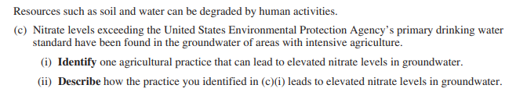

Soil FRQ
Directions: Please answer the question as completely as you possibly can. Turn into the box when you have finished.
Name: ___________________________________________

Question 4e

Soil FRQ
Directions: Please answer the question as completely as you possibly can. Turn into the box when you have finished.
Name: ___________________________________________
Question 4d
