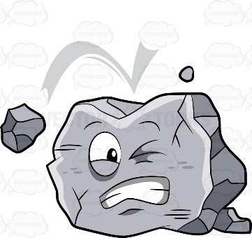
Unit: Soil & Geology
Chps. 7 & 9

Type | Description | Points
Notes | Day 1: Soil & Geology (fill in)
FRQ | Plate Tectonic Theory & Tsunamis Part 1
Notes | Day 2: Plate Tectonics (fill in)
Wkst | Soil & Geology: Half-life: Check yourself
Notes | Day 3: Earthquakes & Volcanoes (handwritten)
Notes | Day 4: Weathering (handwritten)
Notes | Day 5: Soil Formation & Erosion (handwritten-yellow paper)
Notes | Day 6: Soil Properties (fill in)
FRQ | Plate Tectonics Continued (yellow)
Wkst | Soil Textural Triangle with notes
Notes | Day 6a: Soil Degradation
Drawing | Flow Chart
Notes | Day 7: Soil Type in Biomes (fill in)
Activity | Mapping the Ring of Fire
Video | Debunking San Andreas
Article | Dust Bowl Days are Here Again with Article Summary

