Using the Soil Textural Triangle
Approximately 45 minutes
Objectives
By the end of the lesson, students will know or be able to:
- Use the soil textural triangle to distinguish between different types of soil

Materials
- Soil Textural Triangle
- Guided Notes Page – 1 per student
- Guided Practice Page – 1 per student
- Answer key for teachers
Preparatory Work
- Make necessary copies
- Review soil textural triangle use

Enroll the Participants - Use the soil textural triangle to distinguish between different types of soil – Approximately 3 minute

Show a large picture of a Soil Textural Triangle to the class or give each student their own copy of the triangle. Ask if anyone has seen this before or how they believe it’s used. Accept all answers until someone can identify it as a textural triangle used for determining soil texture.

Provide the Experience – Approximately 5 minute

Write the sample problem below on the board. Encourage students to work in small groups to determine the appropriate soil textural class. Allow groups to work together to solve the problem, wait until each group has determined the correct soil textural class.
Sample Problem:
75 % Sand
15% Silt
10% Clay

Answer:
Sandy Loam

Congratulate students for their success in using the soil textural triangle.
Label the Information – Approximately 10 minute

After each group has successfully identified the soil textural class explain to students that they will be writing a “How-to Guide” for this tool. In small groups, encourage students to write step by step instructions for using the soil textural triangle to accurately determine soil textural classes. After about 5 minutes, invite one group to share their “Soil Textural Triangle How to Guide” with the class. Encourage each student to capture these instructions in their own words on their guided notes page.

Demonstrate the Relevance – time varies with students

Encourage students to work through the practice problems on the guided practice sheet. While students are practicing, move through the room offering support and encouragement to students that may find some challenges.

Review the Content – time varies with each group

When the majority of the class is finished, go through the problems as a group and check for understanding. Consider having each student provide an answer to ensure all students have grasped the material.

Celebrate Student Success – Approximately 2 minutes

Thank students for their hard work and focus while demonstrating the use of a soil textural triangle. Congratulate students on their ability to determine appropriate soil textural classes as this is important in crop production, landscape, and even construction. Explain that they will use this information as they determine soil texture and permeability in the land judging competition.
Take a few minutes to preview the next lesson.

Guided Notes: Soil Textural Triangle
Notes Completed by:_________________

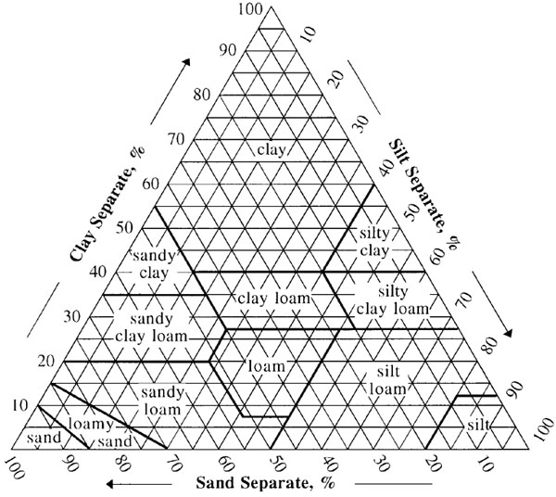

Soil Textural Triangle How-To Guide:

Guided Practice: Soil Textural Triangle
Completed by ______________
Determine the appropriate soil textural class using the soil textural triangle for each problem below:
- 40 % Sand
50% Silt
10% Clay

- 70 % Sand
15% Silt
15% Clay

- 35 % Sand
15% Silt
50% Clay

- 20 % Sand
60% Silt
20% Clay

- 30 % Sand
40% Silt
30% Clay

- Complete the chart using the soil textural triangle.

% Sand | % Silt | % Clay | Texture
5 |  | 50
27 | 35
 | 31 | 33
22 | 23
10 |  | 7
 | 52 | 27

- Which soil textural class do you believe is best for growing plants? Why?

Guided Practice: Soil Textural Triangle KEY
Completed by ______________
Determine the appropriate soil textural class using the soil textural triangle for each problem below:

Silt Loam

Sandy Loam

Clay

Silt Loam

Clay Loam
- 40 % Sand
50% Silt
10% Clay

- 70 % Sand
15% Silt
15% Clay

- 35 % Sand
15% Silt
50% Clay

- 20 % Sand
60% Silt
20% Clay

- 30 % Sand
40% Silt
30% Clay

- Complete the chart using the soil textural triangle.

% Sand | % Silt | % Clay | Texture
5 | 45 | 50 | Silty Clay
27 | 35 | 38 | Clay Loam
36 | 31 | 33 | Clay Loam
22 | 23 | 55 | Clay
10 | 83 | 7 | Silt
52 | 21 | 27 | Sandy Clay Loam

- Which soil textural class do you believe is best for growing plants? Why?

Answers will vary. Consider there are 3 general categories if soil texture: coarse texture (sandy soil); medium texture (loamy soil); and fine texture (clay soils). Coarse soil texture soils warm up faster in the spring. Soils with finer textures hold water and nutrients better than coarse textures. Sandy soils usually have good aeration, but can’t hold water well. So, both water and nutrients can easily leach through the soils. Clay soils retain more water and nutrients than sand, but there is little filtration of the water and less oxygen for the plant due to less pore space than those of coarser textures. Loam is the ideal soil, holding water, nutrients, and oxygen in a balance of sand, clay and organic matter.

