Net Primary Productivity Video and notes

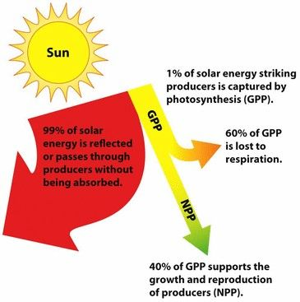
Answer the questions as you watch the video.
https://www.youtube.com/watch?v=cknS7G3Y2bQ

Food = Energy
- Where does the energy for food come from?
- Plants capture sunlight and use it to create ___________________.
- What is biomass?
- What happens to the other 99% of sunlight that is not used for photosynthesis?
- What is GPP?

- Amount of energy that gets transferred is called __________________.
- What does NPP tell us (2 things)?

- What has the highest NPP? Moderate? Least? And why?

- Describe how wetlands and estuaries have a higher NPP than lakes and rivers.

- Fill in the table.

