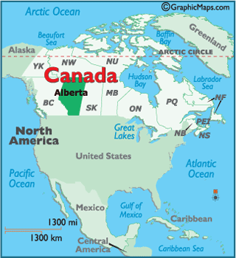
Oil Sands or is it TAR Sands?
Video link: https://www.youtube.com/watch?v=AuSJSRL4sjA
- What is the name of the crude oil that is found on the sand?

- What is the difference between open pit mining and “in-situ” mining?

- What natural resource is used to “in-situ” mine?

- Where are the two largest natural reserves found?

Advantages of Tar/Oil Sands | Environmental & Social Challenges
1.  2. | 1.  2.  3.  4.  5.  6.  7.

